ST. XAVIER’S COLLEGE

**(Affiliated to Tribhuvan University)**

**Maitighar, Kathmandu**



**Computer graphics**

**Lab Assignment #6**

**Draw a Ellipse using midpoint algorithm**

**SUBMITTED BY:**

**Suraj Nepal**

**013BSCCSIT042**

**SUBMITTED TO**

|  |  |
| --- | --- |
| **Er.Anil Sah**  **( Lecturer )** |  |
| **Department of Computer Science** | |

Submission Date: August 25th 2015

**Algorithm:**

Step 1: Input centre (xc,yc) and rx and ry for the ellipse and obtain the first point as

(x0,y0)=(0,ry)

Step 2: Calculate initial decision parameter value in region 1 as

P10=ry2-rx2ry+1/4rx2

Step 3: At each xk position in region 1,starting at k=0,compute xk+1=xk+1

If p1k<0, then the next point to plot is

p1k+1=p1k+2ry2xk+1+ry2

yk+1 = yk

otherwise next point to plot is

yk+1=yk-1

p1k+1=p1k+2ry2xk+1+ry2-2rx2yk+1 with xk+1=xk+1 and yk+1=yk-1

Step 4: Calculate the initial value- of decision parameter at region 2 using last calculated point say (x0,y0) in region 1 as

P20=ry2(x0+1/2)2+rx2(y0-1)2-rx2y2

Step 5: At each yk position in Region 2 starting at k=0, perform computation

Yk+1=y-1;

If p2k>0,then

Xk+1=xk

P2k+1=p2k-2rx2(yk-1)+rx2

Otherwise

Xk+1=xk+1

P2k+1=p2k+2ry2xk+1-2rx2yk+1+rx2

where xk+1=xk+1 and yk+1=yk-1

Step 6: Determine the symmetry points in other 3 quadrants.

Step 7: Move each calculated point (xk, yk) on to the centered (xc,yc) ellipse path as

xk = xk + xc;

yk = yk + yc

Step 8: Repeat the process for region 1 until and region until 2ry2xk>=2rx2yk and region until (xk, yk) =(rx,0)

**Source code:**

//---------------------------------------------------------------------------

#include <vcl\vcl.h>

#pragma hdrstop

#include "Unit1.h"

//---------------------------------------------------------------------------

#pragma resource "*.dfm"

TForm1 *Form1;

int xc,yc,rx,ry,x,y,p;

//---------------------------------------------------------------------------

__fastcall TForm1::TForm1(TComponent* Owner)

: TForm(Owner)

{

}

//---------------------------------------------------------------------------

void __fastcall TForm1::Button1Click(TObject *Sender)

{

xc=StrToInt(Edit1->Text);

yc=StrToInt(Edit2->Text);

rx=StrToInt(Edit3->Text);

ry=StrToInt(Edit4->Text);

x=0;

y=ry;

p=(ry*ry)-(rx*rx*ry)+((rx*rx)/4);

while((2*x*ry*ry)<(2*y*rx*rx))

{

Image1->Canvas->Pixels[xc+x][yc-y]=RGB(155,125,125);

Image1->Canvas->Pixels[xc-x][yc+y]=RGB(125,1,0);

Image1->Canvas->Pixels[xc+x][yc+y]=RGB(0,155,1);

Image1->Canvas->Pixels[xc-x][yc-y]=RGB(155,15,100);

if(p<0)

{

x=x+1;

p=p+(2*ry*ry*x)+(ry*ry);

}

else

{

x=x+1;

y=y-1;

p=p+(2*ry*ry*x+ry*ry)-(2*rx*rx*y);

}

}

p=((float)x+0.5)*((float)x+0.5)*ry*ry+(y-1)*(y-1)*rx*rx-rx*rx*ry*ry;

while(y>=0)

{

Image1->Canvas->Pixels[xc+x][yc-y]=RGB(0,155,100);

Image1->Canvas->Pixels[xc-x][yc+y]=RGB(155,100,0);

Image1->Canvas->Pixels[xc+x][yc+y]=RGB(0,155,100);

Image1->Canvas->Pixels[xc-x][yc-y]=RGB(150,150,150);

if(p>0)

{

y=y-1;

p=p-(2*rx*rx*y)+(rx*rx);

}

else

{

y=y-1;

x=x+1;

p=p+(2*ry*ry*x)-(2*rx*rx*y)-(rx*rx);

}

}

}

//---------------------------------------------------------------------------

**Output:**

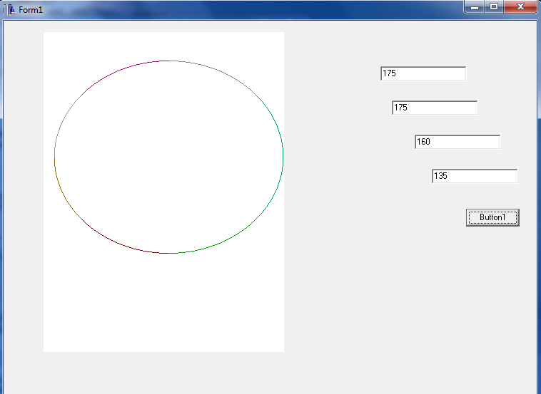

**Conclusion:**

hence an ellipse was drawn in C++ builder using midpoint ellipse algorithm.